**Quantitative Biology Lab II – Jan 28, 2022**

1. **Electrostatic Interactions**

**I.1** Oppositely charged groups in proteins can form electrostatic interactions that are called salt bridges, which is just another word for ion-ion interactions. For instance, an arginine residue (charge of +1 at neutral pH) can form a salt bridge with aspartate (charge of –1 at neutral pH).

**a.** How close do the two charged groups need to be to form a stable interaction in water at 20°C?

Explain in your answer how you define “stable interaction”. (**5 points**)

At 20°C, the relative dielectric constant of water is 80.4. Thus,

$$U = 1389(1)(-1)/(80.4*r)$$

$$r = -17.28/U$$

I will define a stable interaction as having potential energy that is less than the average thermal energy. At 20°C, the average thermal energy is

$(8.314E^{-3})(293)=2.44 kJ/mol$.

Therefore,

$$r = -17.36/-2.44 \sim = 7.08 Angstroms$$

Thus, an arginine and aspartate must be closer than 7.08 Angstroms to form a stable interaction.

**b.** Does the value of the maximum distance for a stable interaction change if the temperature is raised to 37°C? If yes, by how much? If not, why not? (**5 points**)

At 37°C, the relative dielectric constant of water is 76.75. Thus,

$$U = 1389(1)(-1)/(76.75*r)$$

$$r = -18.10/U$$

I have defined a stable interaction as having potential energy that is less than the average thermal energy. At 37°C, the average thermal energy is

$(8.314E^{-3})(310)=2.58 kJ/mol$.

Therefore.

$$r = -18.10/-2.58 \sim = 7.02 Angstroms$$

Thus, an arginine and aspartate must be closer than 7.02 Angstroms to form a stable interaction.

This is a decreased length of .06 Angstroms compared to the case at 20°C. The slight change is due to the fact that the presence of more thermal energy makes it easier for random thermal movement of particles to break the ion-ion interaction.

**I.2** DNA duplexes (helical structures made from two strands of DNA that have negatively charged sugar-phosphate backbones) can be precipitated from aqueous solution that contains monovalent salt ions by the addition of ethanol. Ethanol lowers the dielectric constant of the solvent. Calculate the relative change in the energy of electrostatic interactions between the DNA and cations in solution.

Based on the number that you get, does the interaction become more favorable or more unfavorable? (**5 points**)

The dielectric constants are εH2O = 80 and εEtOH = 24.5.

For simplicity, we are assuming transfer from pure water to pure ethanol (although in practice, the ethanol concentration is 70 – 80%).

We can find the relative favorability of the two interactions by looking at the ratio of their potential energies:

$$\frac{U_{EtOH}}{U_{H2O}} = \frac{\frac{q_{1}q_{2}}{4πr*24.5}}{\frac{q_{1}q_{2}}{4πr*80}}=\frac{1/24.5}{1/80}=\frac{80}{24.5} = 3.27$$

This would suggest that the ion-ion interaction in ethanol has about 3.27 times the amount of potential energy as that in water, which in turn suggests the ethanol interaction is less favorable.

**II. Dipoles**

**II.1** Please address questions in Jupyter notebook section II.1Dipoles (**10 points**)

I found that the dipole moment of adenine has a magnitude of 3.26 D with ⟨x,y⟩ components of ⟨2.55, -2.02⟩.

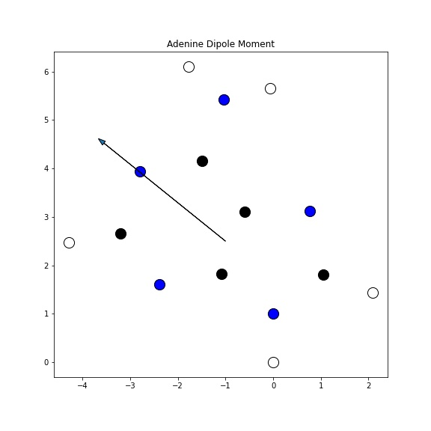

**II.2** 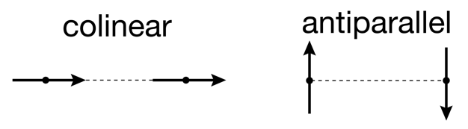Consider two adenine molecules that are oriented in a colinear or in an antiparallel fashion. The distance between their centers is the same in both cases.

For each orientation, is interaction between the dipoles attractive or repulsive? How do their magnitudes compare? (**10 points**)

Only the relative angles of the dipoles are changing in this case, which means distance and vector magnitude remain constant. That means we can say

$$\frac{1389μ_{1}μ_{2}}{{R_{12}}^{3}}=k$$

Which simplifies the potential energy equation to

$$U=\frac{1389μ_{1}μ_{2}}{{R_{12}}^{3}}[cos\left(θ_{12}\right)-3cos⁡(θ_{1})cos⁡(θ_{2})]=k[cos\left(θ_{12}\right)-3cos⁡(θ_{1})cos⁡(θ_{2})]$$

In the colinear case we have $θ_{12}=θ_{1}=θ_{2}=0,$

while for antiparallel we have $θ_{12}={180, θ}_{1}={90, θ}_{2}=270$.

Evaluating the simplified potential energy equation with these values we get

$$U_{colinear}=k\left(1-3*1*1\right)=-2k$$

$$U_{antiparallel}=k\left(-1-3*0*0\right)=-k$$

This suggests that both interactions are attractive because x will be positive for positive distance R12, and therefore -2x and -x will both evaluate to negative values.

Additionally, we can say that because

$$\frac{dk}{dR_{12}}=-3*\frac{1389μ_{1}μ_{2}}{{R_{12}}^{4}}=-3\hat{k}$$

Then

$$F_{colinear}=\frac{dU}{dR_{12}}=\frac{dU}{dk}\frac{dk}{dR_{12}}=-2*-3\hat{k}=6k$$

$$F_{antiparallel}=\frac{dU}{dR_{12}}=\frac{dU}{dk}\frac{dk}{dR_{12}}=-1*-3\hat{k}=3k$$

Therefore, the magnitude of the force of attraction between the dipoles in the colinear case will be twice the magnitude of the dipoles in the antiparallel case.

**II.3** Please address questions in Jupyter notebook section II.3 Dipole-Dipole vs. Ion-Ion interactions. (**5 points**)

I aggregated the terms that would be held constant in both equations (charge, permittivity, etc) into one constant, and then solved for it by plugging in U(3)=1. For dipole-dipole interactions, this gave me U(r)=1/(r^3) while for ion-ion interactions, U(r)=1/r.

